Natural painting

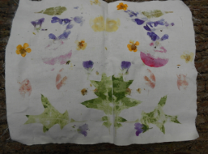

Create an original artwork by bashing petals and leaves onto cloth. This is one of my favourites at this time of year!
Materials required:
- Cotton cloth cut into pieces (old sheets or pillow cases work well, or anything you can find at home pale in colour
- A mallet, hammer or even a log, just something heavy!
- Freshly picked leaves and petals
Method: Explore outside collecting leaves, petals and colourful flowers (some work better than others). Place the petals and leaves onto the cloth and bash them with the mallet! Please do take care not to hit your head, hands or other people around you. For a symmetrical design, place all of the petals and or leaves on one side of the cloth and then fold it over before you begin bashing.

