Model Bird Nests

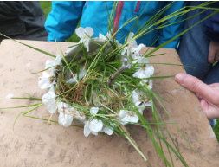

Make your own seasonal nest
Materials required:
- Air drying clay/ plasticine/ make a thick muddy mixture outside if not!
- Natural materials such as sticks, leaves, flowers, mud, moss and feathers
Method: Try and form a small bowl shape out of clay/ mud or plasticine. Then decorate your nest with a range of natural materials of your choice. If desirable, finish off your nest by moulding some eggs and placing them in the nest, ready to hatch!
Many children are only able to identify a handful of birds. Therefore you could extend this activity by having a look to see what birds you may have in the garden/ area near your home or out of the window. If the weather allows lie out on the grass and listen to the different bird calls. The RSPB website has lots of information and if you are unsure of what type of bird you’ve seen check out this site for help! https://www.rspb.org.uk/birds-and-wildlife/wildlife-guides/identify-a-bird/

