Wooden disc/ junk model minibeasts!

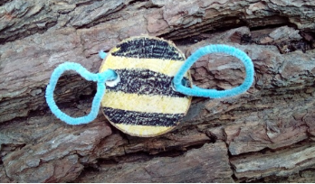

Create real or imaginary creatures out of discs of wood!
Materials required:
- A length of straight(ish) wood, roughly 4 cm in diameter
- A suitable hand saw (we use a bow saw with one child holding it at each end)
- An electric drill, hand drill or palm drill
- Felt tip pens
- Pipe cleaners
Method: Carefully cut 1 cm thick discs of wood. Decide how many legs / wings / antennae your creature should have, and then drill the necessary number of holes around the outer edge of the disc. Use pipe cleaners to make the appendages.
Notes: If you do not have lots of the items above do not worry, any old off cut of timber would be perfect, failing that a junk model minibeast would be just as great! Please see extensions to the activity below….

Activity extension:
Can you build a home for your minibeast? There are lots of ideas using flower pots, old bricks and stones found in the garden. You can also download a bug hunt, which allows you to tally how many of each you can find, take photos too. https://www.twinkl.co.uk/resource/t-t-5270-minibeast-hunt-tally-sheet


