Stick men
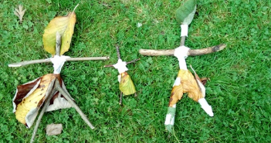

Make a family of stick people to play with, inspired by the story The Stick Man by Julia Donaldson
Materials required:
- One stick with a fork in it (or "Y" shape at the end)
- One straight stick
- Leaves or scraps of material
- Pipe cleaners or masking tape and felt tip pens
Method: The forked stick provides the legs and body, the straight stick the arms. Join the two together by either wrapping a pipe cleaner around them or using a few lengths of masking tape. Give the person hair and or clothes using bits of material, leaves or other natural materials stuck on with masking tape/ or use string to practise that knots and loops. If desired, draw on a face using felt tip pens.
Note: If you don’t have any natural items lollypop sticks and junk modelling materials would be a great substitute.
Activity extension:
Make a home for your stick people! Practise using knots to tie the two sticks together rather than tape. You can use different lengths of sticks to create different characters!

