Wild weaving
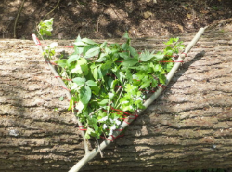

Design your own natural loom for weaving!
Materials required:
- Forked stick
- Wool or string
- Plant or flower stalks
Method: Cut a long length of wool or string and pass it across the forked stick, from top to bottom. Make sure you wrap the thread around the stick once each time you pass it, and pull it nice and tight. Secure the tread at the end with a knot. Weave the stalks in and out (under and over) the thread.
You could also try and make a square frame using 4 lengths of sticks, tying them tightly together.

