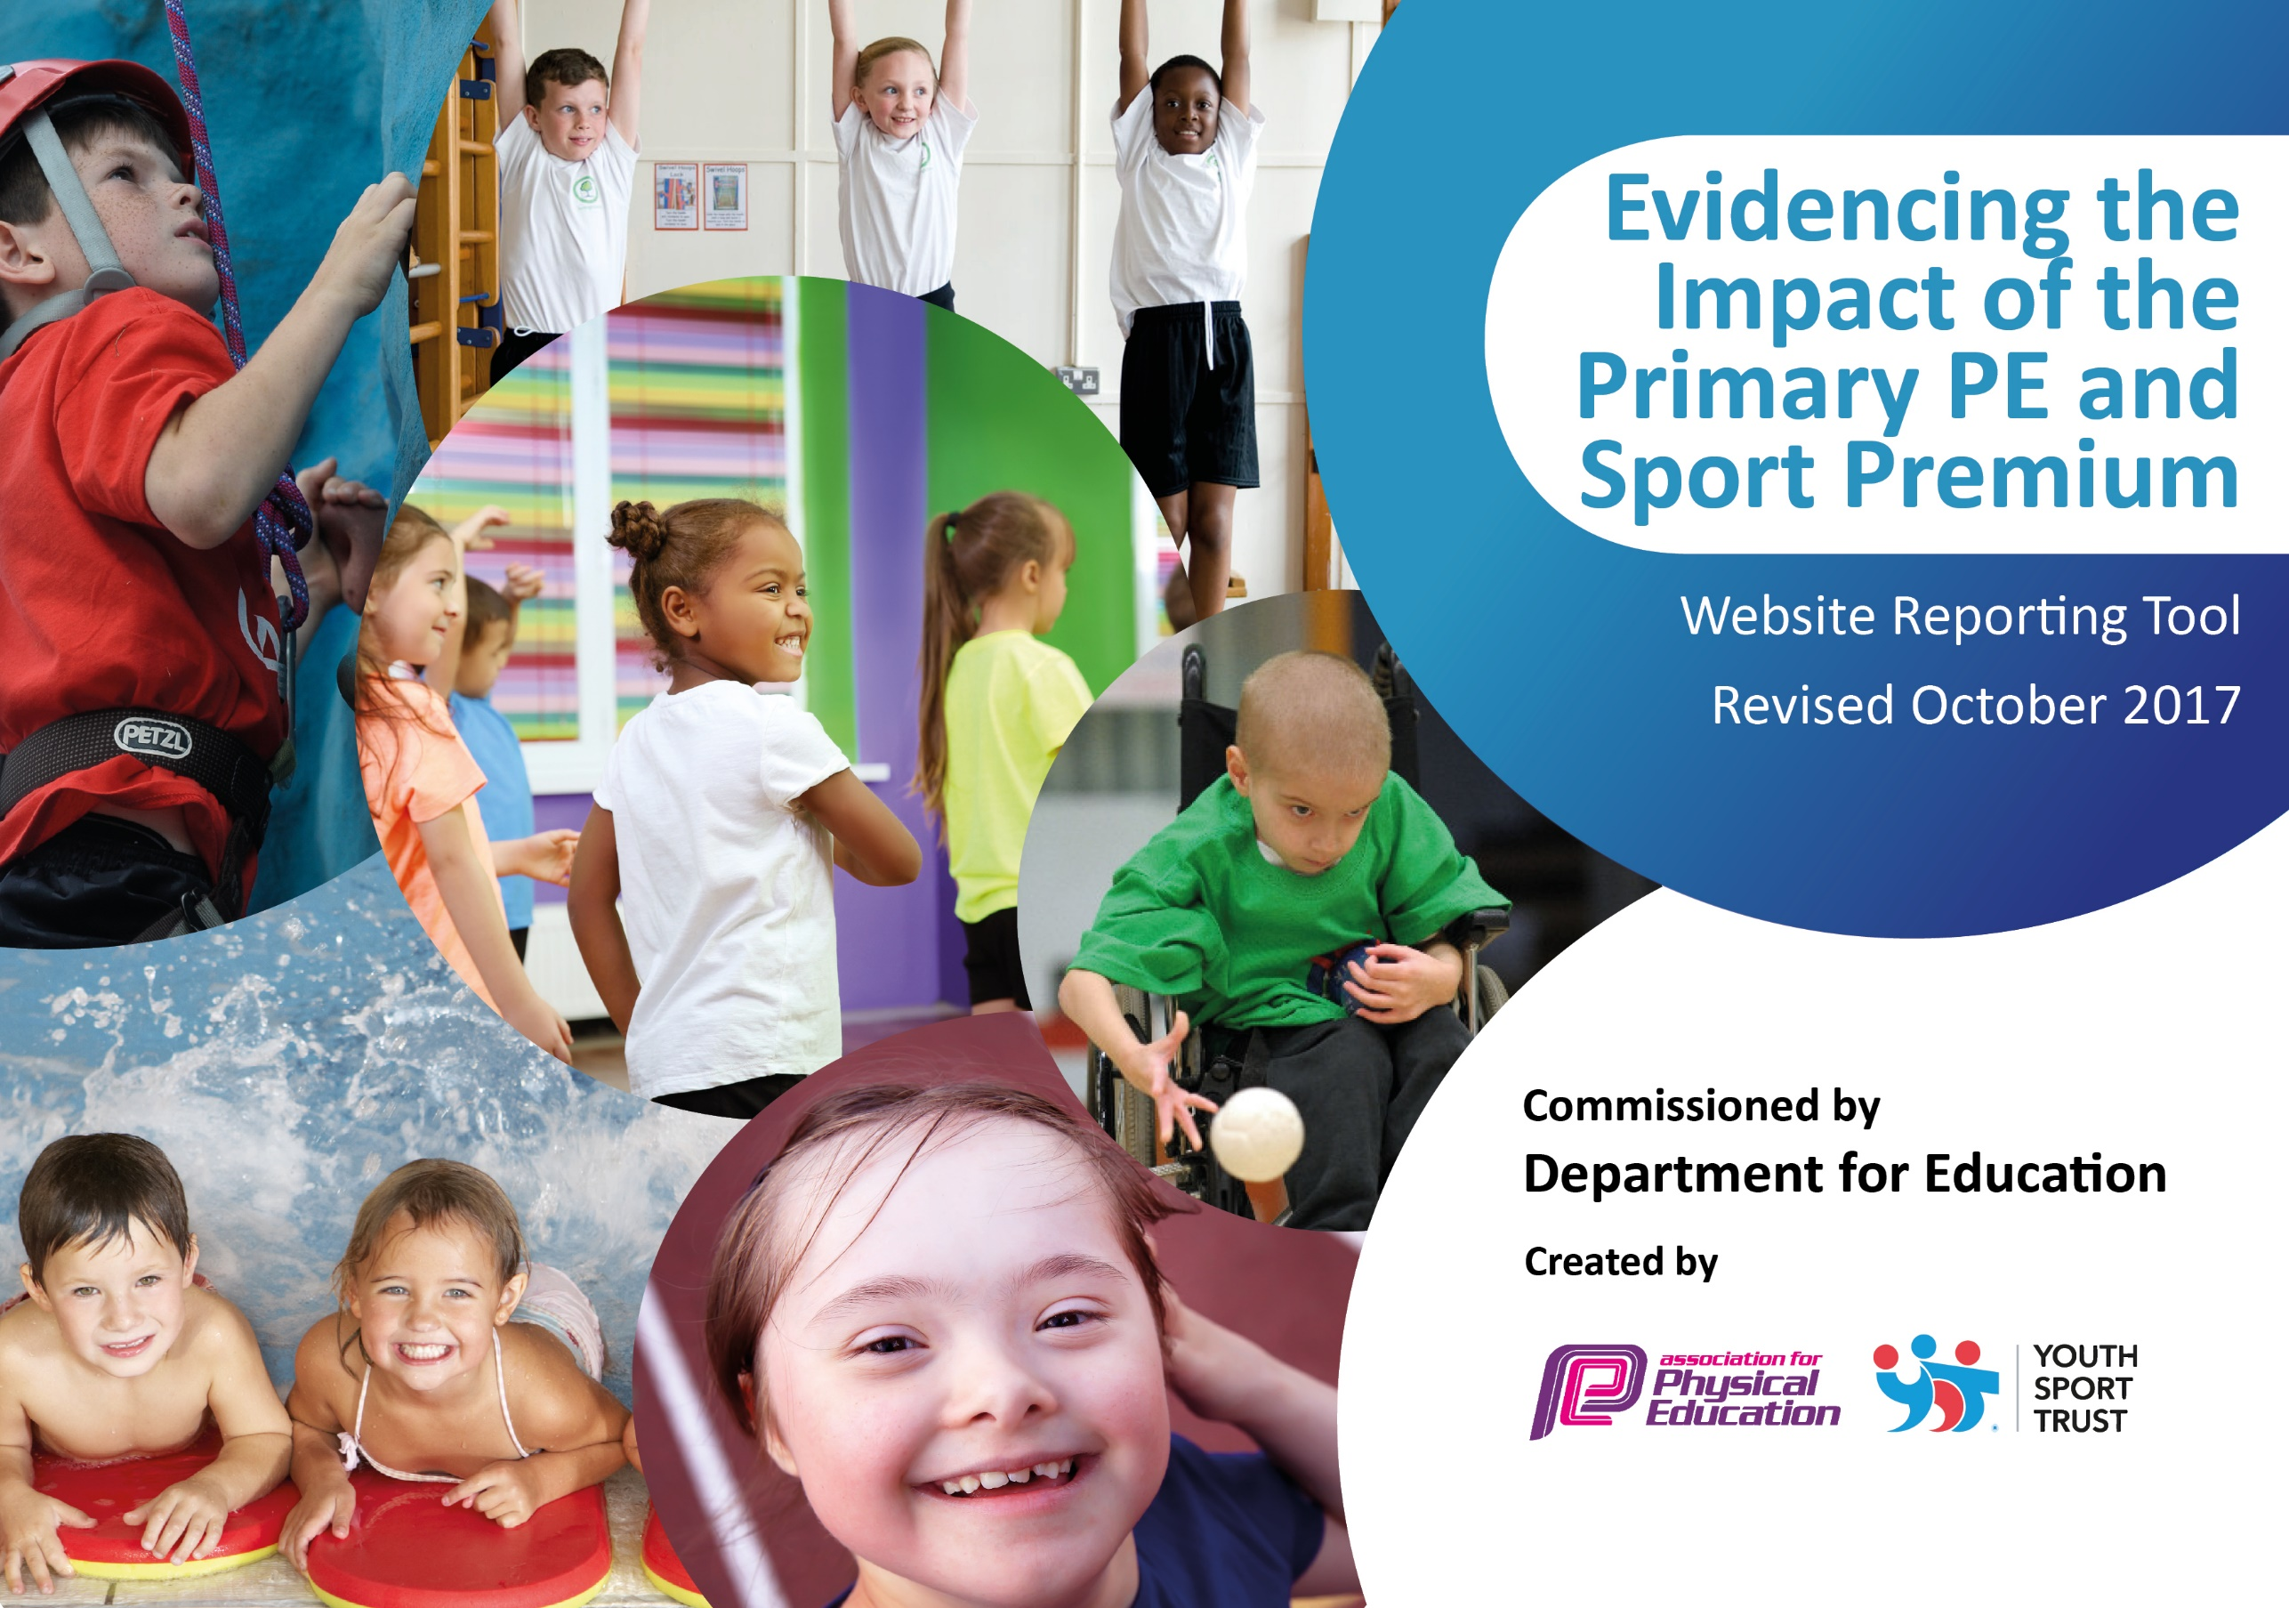

Schools must use the funding to make additional and sustainable improvements to the quality of PE and sport they offer. This means that you should use the Primary PE and Sport Premium to:

- develop or add to the PE and sport activities that your school already offers
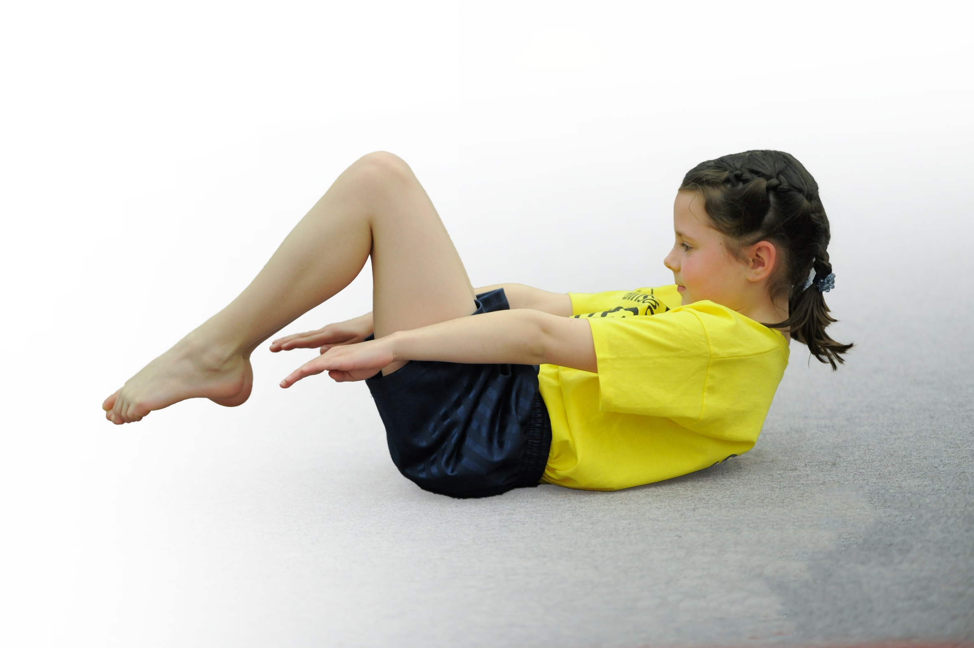
- build capacity and capability within the school to ensure that improvements made now will benefit pupils joining the school in future years

Please visit gov.uk for the revised DfE guidance including the 5 key indicators across which schools should demonstrate an improvement. This document will help you to review your provision and to report your spend. DfE encourages schools to use this template as an effective way of meeting the reporting requirements of the Primary PE and Sport Premium.

We recommend you start by reflecting on the impact of current provision and reviewing the previous spend.
Under the Ofsted Schools Inspection Framework, inspectors will assess how effectively leaders use
the Primary PE and Sport Premium and measure its impact on outcomes for pupils, and how effectively governors hold them to account
for this.

Schools are required to publish details of how they spend this funding as well as on the impact it has on pupils’ PE
and sport participation and attainment.
We recommend regularly updating the table and
publishing it on your website as evidence
of your ongoing review into how you are using the money
to secure maximum, sustainable impact. To see an example of how to complete the table please click HERE.

Support for review and reflection - considering the 5 key indicators from DfE, what development needs are a priority for your setting and your students now and why? Use the space below to reflect on previous spend, identify current need and priorities for the future.

Key achievements to date: | Areas for further improvement and baseline evidence of need:

Meeting national curriculum requirements for swimming and water safety | Please complete all of the below:
What percentage of your Year 6 pupils could swim competently, confidently and proficiently over a distance of at least 25 metres when they left your primary school at the end of last academic year? | All – 80%  Mainstream – 100%
What percentage of your Year 6 pupils could use a range of strokes effectively [for example, front crawl, backstroke and breaststroke] when they left your primary school at the end of last academic year? | All – 80%  Mainstream – 100%
What percentage of your Year 6 pupils could perform safe self-rescue in different water-based situations when they left your primary school at the end of last academic year? | All – 80%  Mainstream – 100%
Schools can choose to use the Primary PE and Sport Premium to provide additional provision for swimming but this must be for activity over and above the national curriculum requirements. Have you used it in this way? | Yes

Action Plan and Budget Tracking
Capture your intended annual spend against the 5 key indicators. Clarify the success criteria and evidence of impact that you intend to measure to evaluate for students today and for the future.

Academic Year: 2021/2022 | Total fund allocated: | Date Updated:
Key indicator 1: The engagement of all pupils in regular physical activity – Chief Medical Officer guidelines recommend that primary school children undertake at least 30 minutes of physical activity a day in school |  |  |  | Percentage of total allocation:
School focus with clarity on intended impact on pupils: | Actions to achieve: | Funding allocated: | Evidence and impact: | Sustainability and suggested next steps:
Key indicator 2: The profile of PE and sport being raised across the school as a tool for whole school improvement |  |  |  | Percentage of total allocation:
School focus with clarity on intended impact on pupils: | Actions to achieve: | Funding allocated: | Evidence and impact: | Sustainability and suggested next steps:
- New football goals will be purchased to improve the profile of football in school |  | £387 | Children used the goals regularly at break during the Summer as well as during some P.E lessons. Children were happy to receive the new goals | Ensure the goals are well looked after and are stored correctly over Winter

Key indicator 3: Increased confidence, knowledge and skills of all staff in teaching PE and sport |  |  |  | Percentage of total allocation:
School focus with clarity on intended  impact on pupils: | Actions to achieve: | Funding  allocated: | Evidence and impact: | Sustainability and suggested  next steps:
- Staff gain in – lesson CPD on a weekly basis | - The employment of a sports apprentice will allow staff to see new games/activities/methods of teaching to enhance their teaching in future lessons | £18030 | Our Sports Apprentice regularly took lessons and after – school clubs and staff felt that their knowledge of how to teach P.E had significantly improved whilst working with the Sports Apprentice | The school will be employing a Sports Apprentice again next year
Key indicator 4: Broader experience of a range of sports and activities offered to all pupils |  |  |  | Percentage of total allocation:
School focus with clarity on intended  impact on pupils: | Actions to achieve: | Funding  allocated: | Evidence and impact: | Sustainability and suggested  next steps:
- Hampton Dene will enter into the Stride Active extra – competition provision |  | £400 | The school entered and the children enjoyed taking part in the competitions – some children have taken up these sports because of it | The school will purchase this package again next year
Key indicator 5: Increased participation in competitive sport |  |  |  | Percentage of total allocation:
School focus with clarity on intended  impact on pupils: | Actions to achieve: | Funding  allocated: | Evidence and impact: | Sustainability and suggested  next steps:
- The school may be able to enter competitions they would previously have been unable to because of budgetary restrictions therefore removing money as a barrier to participation.  - Improved participation/uptake of sporting tournaments | - Money set aside for transport costs to go to local tournaments via private transportation.  - Money set aside for tournament entry costs.  - House competitions provided for KS1 and KS2 so children experience competitive sport in a safe environment.  - The employment of a Sports Apprentice to allow us to send multiple teams to Sports competitions | £520  £18030 | Children enjoyed entering these competitions and the school did well at them – some children have taken up these sports because of it  We have taken two teams to events where we only have previously been able to take one, which has vastly increased the provision for children | With the current financial climate, the same will be done next year to assist Parents

